6. Write a SQL queries to filter and sort data from single data.
Create a table:
create table employees(
id int primary key,
name VARCHAR(100),
department VARCHAR(50),
AGE INT,
salary DECIMAL(10,2)
);

select*from employees;

Insert some sample data:
insert into employees(id,name,department,age,salary)values
(1,'Rohan','TT','26',6000),
(2,'akansha','HR','24',70000),
(3,'vishal','IT','18',30000),
(4,'vaishanavi','MARKETING','23','90000'),
(5,'pranjali','HR','25', 10000);
select*from employees;


Filter records using WHERE:
select*from employees
WHERE department='IT';

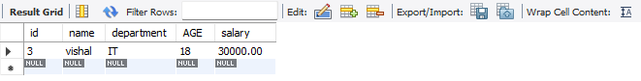

Sort Records Using ORDER BY:
select*from employees
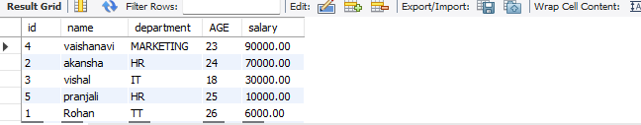
ORDER BY salary DESC;

Combine Filtering and Sorting:
select*from employees
WHERE age>20

ORDER BY age ASC;

